**Function Point Count**

Image result for instant edge logo

**The Enterprise Transformation Platform**

|  |  |
| --- | --- |
|  |  |
|  |  |
|  |  |
|  |  |
|  |  |

|  |  |
| --- | --- |
| Document Reference: | ISS_IE_FPC_2.0 |
| Client: | **I**nstant **E**dge |
| Project: | **I**nstant **E**dge- Manage Operations Module |
| Document Title: | Function point Count |
| Version | 2.0 |
| Date | 8/01/2017 |
| Author | Zhao Pengcheng |

**Amendment History:**

|  |  |  |  |  |
| --- | --- | --- | --- | --- |
| Version | Review & Approval Form Number | Date | Brief description of amendments and affected pages, paragraph | Author |
| 1.0 |  | 20/09/2016 | Initial version | Rameswari Mohanty |
| 2.0 |  | 8/01/2016 | Function point for Sprint 2 | Zhao Pengcheng |

**Team Members:**

|  |  |  |
| --- | --- | --- |
| **Name** | **Group** | **Matriculation No.** |
| Rameswari Mohanty | SE24/4FT | A0148532E |
| Vrinda Gupta | SE24/4FT | A0148518X |
| Vignesh Selvaraju | SE24/4FT | A0148576N |
| Zhao Pengcheng | SE24/4FT | A0148528W |

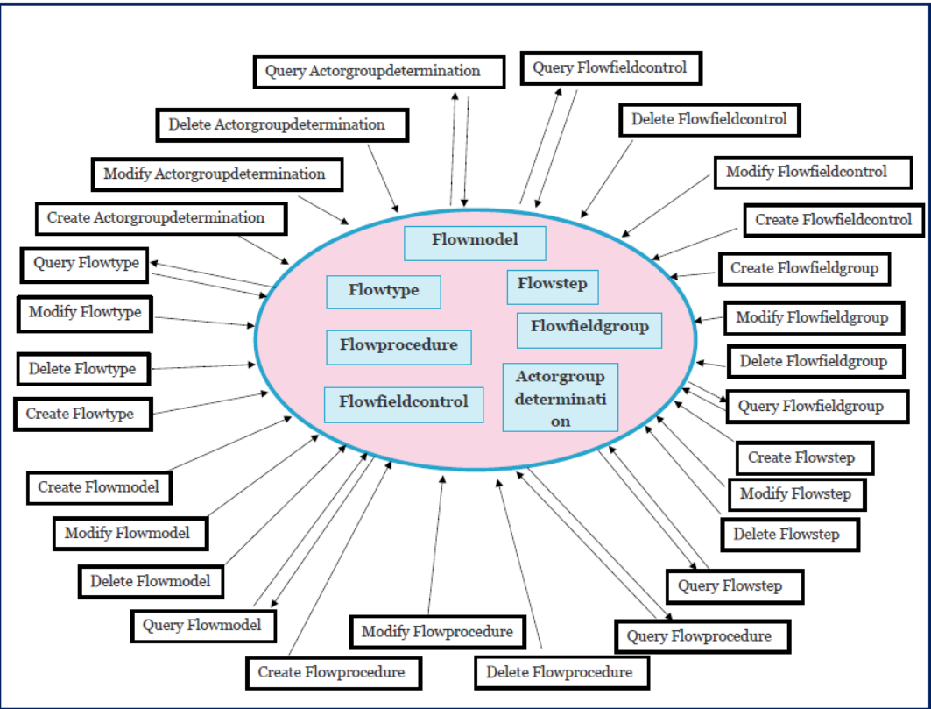

**Data Functions:**

| **Type** | **Description** | **DET** | **RET** | **Complexity** |
| --- | --- | --- | --- | --- |
| **ILF** | **Flowtype** | **4** | **1** | **L** |
|  | Id |  |  |  |
|  | Name |  |  |  |
|  | Description |  |  |  |
|  | Configuration status |  |  |  |
|  |  |  |  |  |
| **ILF** | **Flowmodel** | **4** | **1** | **L** |
|  | Id |  |  |  |
|  | Name |  |  |  |
|  | Description |  |  |  |
|  | ProcessArea |  |  |  |
|  |  |  |  |  |
| **ILF** | **Flowprocedure** | **5** | **1** | **L** |
|  | Id |  |  |  |
|  | Name |  |  |  |
|  | Description |  |  |  |
|  | ProcessArea |  |  |  |
|  | Sequence |  |  |  |
|  |  |  |  |  |
| **ILF** | **Flowstep** | **5** | **1** | **L** |
|  | Id |  |  |  |
|  | Name |  |  |  |
|  | Description |  |  |  |
|  | ProcessArea |  |  |  |
|  | Sequence |  |  |  |
|  |  |  |  |  |
| **ILF** | **Flowfieldgroup** | **7** | **2** | **A** |
|  | Id |  |  |  |
|  | Name |  |  |  |
|  | Description |  |  |  |
|  | language |  |  |  |
|  | Sequence |  |  |  |
|  | Container type |  |  |  |
|  | Uibehavior |  |  |  |
|  |  |  |  |  |
| **ILF** | **Flowfieldcontrol** | **18** | **3** | **H** |
|  | Id |  |  |  |
|  | Name |  |  |  |
|  | Description |  |  |  |
|  | Sequence |  |  |  |
|  | Mandatory |  |  |  |
|  | Disabled |  |  |  |
|  | LabelText |  |  |  |
|  | DefaultText |  |  |  |
|  | Uibehavior |  |  |  |
|  | Business process |  |  |  |
|  | Asset |  |  |  |
|  | Organization |  |  |  |
|  | Impact category |  |  |  |
|  | Priority |  |  |  |
|  | Process area |  |  |  |
|  | Location |  |  |  |
|  | Geographical region |  |  |  |
|  | Urgency |  |  |  |
|  |  |  |  |  |
| **ILF** | **Actorgroupdetermination** | **13** | **2** | **H** |
|  | Id |  |  |  |
|  | Name |  |  |  |
|  | Description |  |  |  |
|  | Sequence |  |  |  |
|  | Organization |  |  |  |
|  | Impact category |  |  |  |
|  | Priority |  |  |  |
|  | Process area |  |  |  |
|  | Location |  |  |  |
|  | Geographical region |  |  |  |
|  | Urgency |  |  |  |
|  | Actor group |  |  |  |
|  | Single actor flag |  |  |  |
|  |  |  |  |  |
|  |  |  |  |  |
|  |  |  |  |  |
|  |  |  |  |  |
|  |  |  |  |  |
|  |  |  |  |  |
|  |  |  |  |  |

**Data Transaction:**

| **Type** | **Description** | **DET** | **FTR** | **Complexity** |
| --- | --- | --- | --- | --- |
| **EI** | **Create Flowtype** | **4** | **1** | **L** |
|  | Name |  |  |  |
|  | Description |  |  |  |
|  | Configuration status |  |  |  |
|  | Error Message |  |  |  |
|  |  |  |  |  |
| **EI** | **Modify Flowtype** | **4** | **1** | **L** |
|  | Name |  |  |  |
|  | Description |  |  |  |
|  | Configuration status |  |  |  |
|  | Error Message |  |  |  |
|  |  |  |  |  |
| **EI** | **Delete Flowtype** | **2** | **1** | **L** |
|  | Id |  |  |  |
|  | Name |  |  |  |
|  |  |  |  |  |
| **EI** | **Create Flowmodel** | **4** | **2** | **L** |
|  | Name |  |  |  |
|  | Description |  |  |  |
|  | ProcessArea |  |  |  |
|  | Error Message |  |  |  |
|  |  |  |  |  |
| **EI** | **Modify Flowmodel** | **4** | **2** | **L** |
|  | Name |  |  |  |
|  | Description |  |  |  |
|  | ProcessArea |  |  |  |
|  | Error Message |  |  |  |
|  |  |  |  |  |
| **EI** | **Delete Flowmodel** | **2** | **2** | **L** |
|  | Id |  |  |  |
|  | Name |  |  |  |
|  |  |  |  |  |
| **EI** | **Create Flowprocedure** | **5** | **2** | **A** |
|  | Name |  |  |  |
|  | Description |  |  |  |
|  | ProcessArea |  |  |  |
|  | Sequence |  |  |  |
|  | Error Message |  |  |  |
|  |  |  |  |  |
| **EI** | **Modify Flowprocedure** | **5** | **2** | **A** |
|  | Name |  |  |  |
|  | Description |  |  |  |
|  | ProcessArea |  |  |  |
|  | Sequence |  |  |  |
|  | Error Message |  |  |  |
|  |  |  |  |  |
| **EI** | **Delete Flowprocedure** | **2** | **2** | **L** |
|  | Id |  |  |  |
|  | Name |  |  |  |
|  |  |  |  |  |
| **EI** | **Create Flowstep** | **5** | **2** | **A** |
|  | Name |  |  |  |
|  | Description |  |  |  |
|  | ProcessArea |  |  |  |
|  | Sequence |  |  |  |
|  | Error Message |  |  |  |
|  |  |  |  |  |
| **EI** | **Modify Flowstep** | **5** | **2** | **A** |
|  | Name |  |  |  |
|  | Description |  |  |  |
|  | ProcessArea |  |  |  |
|  | Sequence |  |  |  |
|  | Error Message |  |  |  |
|  |  |  |  |  |
| **EI** | **Delete Flowstep** | **2** | **2** | **L** |
|  | Id |  |  |  |
|  | Name |  |  |  |
|  |  |  |  |  |
| **EI** | **Create Flowfieldgroup** | **7** | **1** | **L** |
|  | Name |  |  |  |
|  | Description |  |  |  |
|  | language |  |  |  |
|  | Sequence |  |  |  |
|  | Container type |  |  |  |
|  | Uibehavior |  |  |  |
|  | Error Message |  |  |  |
|  |  |  |  |  |
| **EI** | **Modify Flowfieldgroup** | **7** | **1** | **L** |
|  | Name |  |  |  |
|  | Description |  |  |  |
|  | language |  |  |  |
|  | Sequence |  |  |  |
|  | Container type |  |  |  |
|  | Uibehavior |  |  |  |
|  | Error Message |  |  |  |
|  |  |  |  |  |
| **EI** | **Delete Flowfieldgroup** | **2** | **1** | **L** |
|  | Id |  |  |  |
|  | Name |  |  |  |
|  |  |  |  |  |
| **EI** | **Create Flowfieldcontrol** | **18** | **2** | **H** |
|  | Name |  |  |  |
|  | Description |  |  |  |
|  | Sequence |  |  |  |
|  | Mandatory |  |  |  |
|  | Disabled |  |  |  |
|  | LabelText |  |  |  |
|  | DefaultText |  |  |  |
|  | Uibehavior |  |  |  |
|  | Business process |  |  |  |
|  | Asset |  |  |  |
|  | Organization |  |  |  |
|  | Impact category |  |  |  |
|  | Priority |  |  |  |
|  | Process area |  |  |  |
|  | Location |  |  |  |
|  | Geographical region |  |  |  |
|  | Urgency |  |  |  |
|  | Error Message |  |  |  |
|  |  |  |  |  |
| **EI** | **Modify Flowfieldcontrol** | **18** | **2** | **H** |
|  | Name |  |  |  |
|  | Description |  |  |  |
|  | Sequence |  |  |  |
|  | Mandatory |  |  |  |
|  | Disabled |  |  |  |
|  | LabelText |  |  |  |
|  | DefaultText |  |  |  |
|  | Uibehavior |  |  |  |
|  | Business process |  |  |  |
|  | Asset |  |  |  |
|  | Organization |  |  |  |
|  | Impact category |  |  |  |
|  | Priority |  |  |  |
|  | Process area |  |  |  |
|  | Location |  |  |  |
|  | Geographical region |  |  |  |
|  | Urgency |  |  |  |
|  | Error Message |  |  |  |
|  |  |  |  |  |
| **EI** | **Delete Flowfieldcontrol** | **2** | **2** | **L** |
|  | Id |  |  |  |
|  | Name |  |  |  |
|  |  |  |  |  |
| **EI** | **Create Actorgroupdetermination** | **13** | **2** | **A** |
|  | Name |  |  |  |
|  | Description |  |  |  |
|  | Sequence |  |  |  |
|  | Organization |  |  |  |
|  | Impact category |  |  |  |
|  | Priority |  |  |  |
|  | Process area |  |  |  |
|  | Location |  |  |  |
|  | Geographical region |  |  |  |
|  | Urgency |  |  |  |
|  | Actor group |  |  |  |
|  | Single actor flag |  |  |  |
|  | Error Message |  |  |  |
|  |  |  |  |  |
| **EI** | **Modify Actorgroupdetermination** | **13** | **2** | **A** |
|  | Name |  |  |  |
|  | Description |  |  |  |
|  | Sequence |  |  |  |
|  | Organization |  |  |  |
|  | Impact category |  |  |  |
|  | Priority |  |  |  |
|  | Process area |  |  |  |
|  | Location |  |  |  |
|  | Geographical region |  |  |  |
|  | Urgency |  |  |  |
|  | Actor group |  |  |  |
|  | Single actor flag |  |  |  |
|  | Error Message |  |  |  |
|  | Description |  |  |  |
|  |  |  |  |  |
| **EI** | **Delete Actorgroupdetermination** | **2** | **2** | **L** |
|  | Id |  |  |  |
|  | Name |  |  |  |
|  |  |  |  |  |
| **EQ** | **Query Flowtype** |  |  | **L** |
|  | Input | 2 | 1 |  |
|  | Name |  |  |  |
|  | Configuration status |  |  |  |
|  | Output | 3 | 1 |  |
|  | Name |  |  |  |
|  | Description |  |  |  |
|  | Configuration status |  |  |  |
|  |  |  |  |  |
| **EQ** | **Query Flowmodel** |  |  | **L** |
|  | Input | 2 | 2 |  |
|  | Name |  |  |  |
|  | Flowtype |  |  |  |
|  | Output | 4 | 2 |  |
|  | Name |  |  |  |
|  | Description |  |  |  |
|  | ProcessArea |  |  |  |
|  | Flowtype |  |  |  |
|  |  |  |  |  |
| **EQ** | **Query Flowprocedure** |  |  | **A** |
|  | Input | 3 | 3 |  |
|  | Name |  |  |  |
|  | Flowtype |  |  |  |
|  | Flowmodel |  |  |  |
|  |  |  |  |  |
|  | Output | 6 | 3 |  |
|  | Name |  |  |  |
|  | Description |  |  |  |
|  | ProcessArea |  |  |  |
|  | Sequence |  |  |  |
|  | Flowmodel |  |  |  |
|  | Flowtype |  |  |  |
|  |  |  |  |  |
| **EQ** | **Query Flowstep** |  |  | **H** |
|  | Input | 4 | 4 |  |
|  | Name |  |  |  |
|  | Flowtype |  |  |  |
|  | Flowmodel |  |  |  |
|  | Flowprocedure |  |  |  |
|  | Output | 7 | 4 |  |
|  | Name |  |  |  |
|  | Description |  |  |  |
|  | ProcessArea |  |  |  |
|  | Sequence |  |  |  |
|  | Flowmodel |  |  |  |
|  | Flowtype |  |  |  |
|  | Flowprocedure |  |  |  |
|  |  |  |  |  |
| **EQ** | **Query Flowfieldgroup** |  |  | **L** |
|  | Input | 1 | 1 |  |
|  | Name |  |  |  |
|  | Output | 6 | 1 |  |
|  | Name |  |  |  |
|  | Description |  |  |  |
|  | language |  |  |  |
|  | Sequence |  |  |  |
|  | Container type |  |  |  |
|  | Uibehavior |  |  |  |
|  |  |  |  |  |
| **EQ** | **Query Flowfieldcontrol** |  |  | **A** |
|  | Input | 2 | 2 |  |
|  | Name |  |  |  |
|  | Flowprocedure |  |  |  |
|  | Output | 18 | 2 |  |
|  | Name |  |  |  |
|  | Description |  |  |  |
|  | Sequence |  |  |  |
|  | Mandatory |  |  |  |
|  | Disabled |  |  |  |
|  | LabelText |  |  |  |
|  | DefaultText |  |  |  |
|  | Uibehavior |  |  |  |
|  | Business process |  |  |  |
|  | Asset |  |  |  |
|  | Organization |  |  |  |
|  | Impact category |  |  |  |
|  | Priority |  |  |  |
|  | Process area |  |  |  |
|  | Location |  |  |  |
|  | Geographical region |  |  |  |
|  | Urgency |  |  |  |
|  | Flowprocedure |  |  |  |
|  |  |  |  |  |
| **EQ** | **Query Actorgroupdetermination** |  |  | **H** |
|  | Input | 2 | 5 |  |
|  | Name |  |  |  |
|  | Flowtype |  |  |  |
|  | Flowmodel |  |  |  |
|  | Flowprocedure |  |  |  |
|  | Flowstep |  |  |  |
|  | Output | 16 | 5 |  |
|  | Name |  |  |  |
|  | Description |  |  |  |
|  | Sequence |  |  |  |
|  | Organization |  |  |  |
|  | Impact category |  |  |  |
|  | Priority |  |  |  |
|  | Process area |  |  |  |
|  | Location |  |  |  |
|  | Geographical region |  |  |  |
|  | Urgency |  |  |  |
|  | Actor group |  |  |  |
|  | Single actor flag |  |  |  |
|  | Flowtype |  |  |  |
|  | Flowmodel |  |  |  |
|  | Flowprocedure |  |  |  |
|  | Flowstep |  |  |  |

**Unadjusted Function Point count summary:**

|  |  |  |  |  |
| --- | --- | --- | --- | --- |
| **ITEM** | **LOW** | **AVERAGE** | **HIGH** | **TOTAL** |
| External Input | 13*3=39 | 6*4=24 | 2*6=12 | 75 |
| External Output | 0*4=4 | 0*5=5 | 0*7=0 | 0 |
| Internal File | 4*7=28 | 1*10=10 | 2*15=30 | 68 |
| Interface file | 0*5=0 | 0*7=0 | 0*10=0 | 0 |
| External Inquiry | 3*3=9 | 2*4=8 | 2*6=12 | 29 |
|  |  | Unadjusted | Function Points = | 172 |

|  |  |  |
| --- | --- | --- |
| **CHARACTERISTIC** | **DI** |  |
| Data Communications | 3 | It supports online data updating |
| Distributed Functions | 3 | Data is transferred via web and mobile applications |
| Performance | 3 | The system must respond in real time |
| Heavily Used Configuration | 3 | Much configuration data for end users done by root |
| Transaction Rate | 1 | Cloud based application, no certain requirements for now |
| Online Data Entry | 1 | All transactions are directly entered into system |
| End User Efficiency | 3 | System should be easy and efficient to use |
| Online Update | 3 | All of the major data files shall be updated online |
| Complex Processing | 4 | Complicated business logic |
| Re-usability | 2 | The code should be modular and reusable |
| Installation Ease | 2 | Deployed on cloud |
| Operational Ease | 2 | Certain operation responsibilities for root user and architect |
| Multiple Sites | 0 | Single site |
| Facilitate Change | 0 | Nothing said |
| **Total Degree of Influence** | 30 |  |

Adjusted FPC = Unadjusted FPC * Adjustment Factor = 172 * (0.65 + 0.01*30) = 163.4

